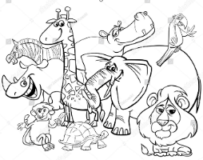
Podpis: _________________ SAFARI

ST – napiš, co nejvíce slov začínajících na písmeno.    P  VŠECHNY ŘÁDKY POPIŠ SLOVY! | ___________________________________________________________________  …………………………………………………………………………………………  ___________________________________________________________________
___________________________________________________________________
…………………………………………………………………………………………
___________________________________________________________________

___________________________________________________________________
…………………………………………………………………………………………
___________________________________________________________________

___________________________________________________________________
…………………………………………………………………………………………
___________________________________________________________________

___________________________________________________________________
…………………………………………………………………………………………
___________________________________________________________________

ST – napiš na první dva řádky slova s Ú na začátku.  Ú - Ů  Na další dva s Ů uvnitř nebo na konci.  VYUŽIJ APLIKACI | ___________________________________________________________________  …………………………………………………………………………………………  ___________________________________________________________________

___________________________________________________________________
…………………………………………………………………………………………
___________________________________________________________________

___________________________________________________________________
…………………………………………………………………………………………
___________________________________________________________________

___________________________________________________________________
…………………………………………………………………………………………
___________________________________________________________________

ČT – NAPIŠ SLOVA PODŘAZENÁ  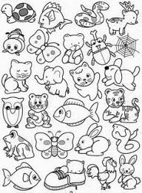  ZVÍŘATA | ___________________________________________________________________  …………………………………………………………………………………………  ___________________________________________________________________
___________________________________________________________________
…………………………………………………………………………………………
___________________________________________________________________

___________________________________________________________________
…………………………………………………………………………………………
___________________________________________________________________

___________________________________________________________________
…………………………………………………………………………………………
___________________________________________________________________

___________________________________________________________________
…………………………………………………………………………………………
___________________________________________________________________

PÁ - z daných slov vykouzli slova v rozkazovacím  tvaru.  PŘ: zametat – zametej | stát | ______________________  …………………………….  ______________________ | držet | ______________________  …………………………….  ______________________
 | čekat | ______________________  …………………………….  ______________________ | kreslit | ______________________  …………………………….  ______________________
 | učit se | ______________________  …………………………….  ______________________ | lepit | ______________________  …………………………….  ______________________
 | ležet | ______________________  …………………………….  ______________________ | volat | ______________________  …………………………….  ______________________
 | sedět | ______________________  …………………………….  ______________________ | myslet | ______________________  …………………………….  ______________________
 | přát | ______________________  …………………………….  ______________________ | uklízet | ______________________  …………………………….  ______________________

